Washington State Association of School Psychologists
Professional Learning March 19, 2021
Dr. Sarah M. Lupo

Session 1: Comprehension
Learning Objectives
- Understand the process of comprehension and models that support instruction, including the role of knowledge
- Understand the research behind text complexity and how to analyze texts

Anticipation Guide
Directions: Please read the following statements and decide if you agree or disagree with each statement. Later, we will come back to these statements and discuss.

 | Before Reading | After Reading | Ideas or Thoughts
1. Texts can be easily leveled (Lexile, grade level) to determine the challenges they present to readers.
2. Below grade level readers make the most amount of growth when provided with opportunities to read a variety of texts, both challenging and easier, with appropriate scaffolds.
3. Teaching comprehension is mostly about teaching students to find the main idea, making inferences, or identifying the authors’ purpose.
4. It is important to keep skills in mind as you are selecting texts, such as how to find the main idea or author’s purpose.
5. Background knowledge is defined as knowledge of facts and vocabulary related to science, social studies, and math.
6. Knowledge has a small but important influence on a students’ comprehension.

Explain one thing you learned or was confirmed about how children comprehend.

Text Analysis
Directions: Read the following short text and ask yourself these four questions:
  - What background knowledge does the author assume the reader has, and does the reader have that knowledge?
  - Are there multiple meanings or abstract concepts/themes?
  - Are students familiar with most of the words? Are there are a lot of academic words, complex syntax, discipline specific words, or figurative language?
  - Is this text structured in a way that makes it easy to understand (i.e., good use of headings) or is the structure of the text complicated (i.e., does the reader have to infer how ideas are connected)?

Pacific Cod: The Ageing of a Difficult Species
Historically, fish scales and otoliths have been the two most common structures used for determining the ages of fish species. Unfortunately, age-readers employing these structures have experienced limited success in the case of Pacific cod.

Text Feature | Challenges | Example
Knowledge
Meaning
Language
Structure

Try analyzing another passage!

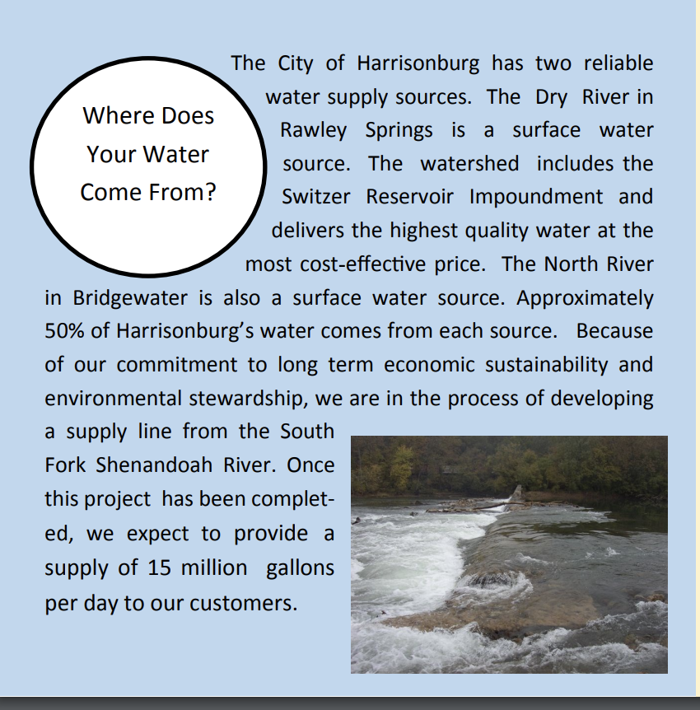
Retrieved from: https://www.harrisonburgva.gov/ water-quality

Text Feature | Challenges | Example
Knowledge
Meaning
Language
Structure

*Answers in the PPT slides handout

Knowledge:
Write down one thing you will share with your colleagues about knowledge.
Session 2: Selecting Texts
Learning Objectives
- Understand the various goals of texts to guide thoughtful text selection
- Learn how to create select texts using the quad text set framework

Additional examples of Quad Text Sets.

Middle School Social Studies:

Elementary Social Studies:

High School Science:

Elementary Science:

How might you use quad text sets in your schools?
Session 3: Scaffolding Comprehension
Learning Objectives
- Understand how to support readers’ comprehension before, during, and after reading
- Grow a toolbox of strategies to use to support reader’s comprehension

Pre-post Journal
Directions:, Write down some ideas about the following prompt. You will come back to this journal later and add some new ideas:
- How do you scaffold and support readers when they engage with rigorous texts?

BEFORE READING

House Reading
Directions Read the following passage and underline the main idea and most important details from the passage.

The House
The two boys ran until they came to the driveway. “See, I told you today was good for skipping school,” said Mark. “Mom is never home on Thursday,” He added. Tall hedges hid the house from the road so the pair strolled across the finely landscaped yard. “I never knew your place was so big,” said Pete. “Yeah, but it’s nicer now than it used to be since Dad had the new stone siding put on and added the fireplace.”
There were front and back doors and a side door that led to the garage, which was empty except for three parked 10-speed bikes. They went in the side door, Mark explaining that it was always open in case his younger sisters got home earlier than their mother.
Pete wanted to see the house so Mark started with the living room. It, like the rest of the downstairs, was newly painted. Mark turned on the stereo, the noise of which worried Pete. “Don’t worry, the nearest house is a quarter mile away,” Mark shouted. Pete felt more comfortable observing that no houses could be seen in any direction beyond the huge yard.
The dining room, with all the china, silver, and cut glass, was no place to play so the boys moved into the kitchen where they made sandwiches. Mark said they wouldn’t go to the basement because it had been damp and musty ever since the new plumbing had been installed.
“This is where my Dad keeps his famous paintings and his coin collection,” Mark said as they peered into the den. Mark bragged that he could get spending money whenever he needed it since he’d discovered that his Dad kept a lot in the desk drawer.
There were three upstairs bedrooms. Mark showed Pete his mother’s closet that was filled with furs and the locked box that held her jewels. His sisters' room was uninteresting except for the color TV that Mark carried to his room. Mark bragged that the bathroom in the hall was his since one had been added to his sisters' room for their use. The big highlight in his room, though, was a leak in the ceiling where the old roof had finally rotted.
References: Chris Tovani (2000) Picher and Anderson (1977)

Probable Passage

Words: Egyptian, receded, desert, Nile, 6,000 B. C. E., silt, canals, irrigation, papyrus, barren, Sahara, farming

Setting

Characters

Resolution

Problem

Gist Statement:
_________________________________________________________________________________________________________________________________________________________________________________________________________________________________________

Life along the Nile

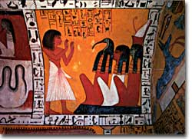
The ancient Egyptian writing system, hieroglyphics, was advanced by 3100 B.C.E. The complex system included numbers and an alphabet as well as other symbols.
None of the achievements of the remarkable ancient Egyptian civilization would have been possible without the Nile River. There is always a connection between landscape and how a people develop. It does not take the wisdom of a sphinx to understand why.
Archaeologists and historians don't know exactly how Egyptian civilization evolved. It is believed that humans started living along the Nile's banks starting in about 6,000 B.C.E. For the earliest inhabitants of the Nile Valley food was not easy to find. There were no McTut's selling burgers, and, though there were a lot of crocodiles, those critters were pretty hard to catch.

Food for Thought
Over time, however, despite being in the midst of desert surroundings, people discovered that the Nile River provided many sources of food. Along the river were fruit trees, and fish swam in the Nile in great numbers.
The Nile — the longest river in the world at 4,187 miles — defines Egypt's landscape and culture. A common Egyptian blessing is "May you always drink from the Nile."
Perhaps most importantly, they discovered that, at the same time each year, the Nile flooded for about six months. As the river receded, it deposited a rich, brown layer of silt that was suitable for growing wheat, beans, barley, or even cotton. Farmers learned to dig short canals leading to fields near the Nile, thus providing fresh water for year-round irrigation. Planting immediately after a flood yielded harvests before the next year's flood.

Prime Time
In order to know when to plant, the Egyptians needed to track days. They developed a calendar based on the flooding of the Nile that proved remarkably accurate. It contained a year of 365 days divided into 12 months of 30 days each. The five extra days fell at the end of the year.
Here's a problem that the sphinx might have trouble answering: how did the ancient Egyptians make their calendars? What material did they use? Remember, there was no paper. Need a clue? Take a dip in the Nile.
Large reeds called papyrus grew wild along the Nile. The Egyptians developed a process that turned these reeds into flattened material that could be written on (also called papyrus). In fact, the English word "paper" has its root in the ancient Greek word "papyrus." Among the first things written on papyrus were calendars that tracked time.
Papyrus had many other uses. Boats were constructed by binding the reeds together in bundles. Baskets, mats, rope, and sandals were also fashioned from this multipurpose material.

Sand, Land, and Civilization
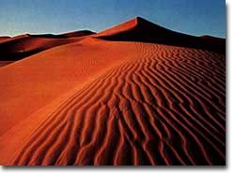
The Sahara, the world's largest desert, encroaches on the western shore of the Nile River. Other deserts lie to the Nile's east. Egypt's location within the world's driest region helped protect it from invaders throughout the centuries.
Even today, the world around the Nile is quite barren. Outside of the narrow swath of greenery next to the river, there is sand as far as the eye can see. To the Nile's west exists the giant Sahara Desert, the largest desert in the world.
From north to south, the Sahara is between 800 and 1,200 miles wide; it stretches over 3,000 miles from east to west. The total area of the Sahara is more than 3,500,000 square miles. It's the world's biggest sandbox.
And, as if there weren't enough sand in the Sahara, east of the Nile are other deserts.
Although sand had limited uses, these deserts presented one tremendous strategic advantage: few invaders could ever cross the sands to attack Egypt — the deserts proved too great a natural barrier.
After learning to take advantage of the Nile's floods — and not having to fear foreign attacks — the Egyptians concentrated on improving farming techniques. As the years passed, Egyptians discovered that wheat could be baked into bread, that barley could be turned into soup (or even beer), and that cotton could be spun into clothing.
With many of life's necessities provided, the Egyptians started thinking about other things, such as art, government, religion, and philosophy — some of the basics needed to create a civilization. Eventually, pyramids, mummies, Cleopatra, and the Sphinx of Giza became touchstones of this flourishing culture.

Think of a text that students may read. How can you support students’ comprehension before reading?

DURING READING
Check out Dr. Wright of MSU engaging an interactive read aloud with a Kindergarten class here: https://tinyurl.com/interactiveRA

Excerpt Retrieved from: https://www.popsci.com/hurricane-flood-pig-poop:

“During a hurricane, where does all the pig poop go? Into your water.
The horrifying pig poop floods in North Carolina are not a one-time thing.
By Jennifer Lu September 25, 2018

Hurricane Florence inundated at least 54 lagoons full of pig excrement when it made landfall September 14 and unloaded at least 8 trillion gallons of rainfall over North Carolina in less than a week. The record rainfall may be a new one for the history books, but the slurry of hog poop, urine, bristles, dead skin, and bacteria that’s sloshed into the environment is déjà vu twice over.

In 1999, Hurricane Floyd contaminated the rivers, wells, and groundwater of rural eastern North Carolina in animal waste, much of it having escaped from loosely-regulated industrial hog farms. In 2016, during Hurricane Matthew, 14 such lagoons spilled over.

Growers on industrial scale hog farms use massive, open-air lagoons the size of football fields to store hog waste while bacteria (which give the lagoons their dull pink color) break it down and turn it into fertilizer that can be sprayed onto fields. To keep the lagoons from filling to the brim, facilities are required to keep a clearance of 19 inches between the wastewater level and the top of the berm, a gap that's known as the freeboard distance. All new swine lagoons in North Carolina must be leak-proof, while existing lagoons must be able to withstand a 25-year, 24-hour rain event, or rainfall that has a four percent chance of happening in any given year.

The problem is, that statistical standard has become outdated—particularly because climate change is causing more frequent and intense storms, says Michelle Nowlin, a law professor and supervising attorney at the Duke Environmental Law and Policy Clinic.

Rain and flood water from Hurricane Florence, a 1000-year event, overtopped 31 lagoons, inundated 23, and left 76 in danger of overflowing as of Friday noon, according to the North Carolina Department of Environmental Quality. As of Sunday noon, five lagoons were reported to have structure damage, though the number of flooded lagoons fell to 41, with 57 still in danger of overflowing. (The water has also breached a dam that flooded two basins at a Duke Energy power plant holding toxic ash residues leftover from burning coal.)

Think Aloud Example

Text | Teacher Script | Strategies modeled/practiced
Hurricane Florence inundated at least 54 lagoons full of pig excrement when it made landfall September 14 | I’m not sure what the word excrement means. Could it mean parts of a pig? The root ex means “out of”, which makes me think that maybe they mean something that comes out of a pig, like poop. That makes sense based on the title. | Vocabulary  Using roots and context to figure out unknown words
 | So, people are keeping lagoons full of pig poop? I wonder why. I wonder if they use the poop for something on their farms, like fuel. | Comprehension  predictions
In 1999, Hurricane Floyd contaminated the rivers, wells, and groundwater of rural eastern North Carolina in animal waste, much of it having escaped from loosely-regulated industrial hog farms. In 2016, during Hurricane Matthew, 14 such lagoons spilled over. | The wording “loosely regulated” here makes me think that this article is going to talk about how regulations for how pig farms store poop might be poor. I predict the article will suggest increasing regulations. | Comprehension  predictions
Growers on industrial scale hog farms use massive, open-air lagoons the size of football fields to store hog waste while bacteria (which give the lagoons their dull pink color) break it down and turn it into fertilizer that can be sprayed onto fields. | Ok, so they are using the pig poop for fertilizer. | Comprehension  predictions

Students Turn:
Text | Teacher Script | Strategies modeled/practiced
To keep the lagoons from filling to the brim, facilities are required to keep a clearance of 19 inches between the wastewater level and the top of the berm, a gap that's known as the freeboard distance. | With a partner, see if you can figure out the word berm | Vocabulary  Using context to figure out unknown words
When lagoons spill over, they add to the environmental and public health burdens on communities that live nearby. Individual pig growers are responsible for cleaning up the messes on their properties, but local communities bear the brunt of any fecal contamination to their drinking water, Nowlin says. | So, people are now getting poop in their drinking water because of the farmers’ practices, but the farmers don’t have to clean up their mess. What do you predict the financial impact is for the local people? How about the pig farmers, if they have to start cleaning up their messes? | Comprehension  predictions

Think Aloud

Lapp, Fisher, and Grant (2008) discuss how to design a think aloud in order to model your thinking of a challenging nonfiction text for students.

- Select a couple of (short!) segments of your text to read aloud to your students.
- Select a part of that text that students may find confusing (for example, challenging vocabulary, confusing phrasing, unknown text features or structure).
- Select a strategy to model for your students to demonstrate how you make sense of the challenging text (for example, making predictions or connections, using context clues or word parts to identify word meanings, how you use text structure or features to understand the text)
- Write a script of what you will say during your think aloud to model how you grapple with the challenging text (see Lapp, Fisher, and Grant for examples).
- Provide an opportunity for your students to practice the same kind of thinking with another part of this text.

Title of text: ____________________________

Text | Teacher Script | Strategies modeled/practiced

The Discovery of Edison's Light Bulb

VOCABULARY  Someone who makes something new  The path electricity takes | Can you imagine what life was like before you could flip a switch and turn on a light? How would not having electric light affect the way you live your life?  In the 1870s, many inventors were working on creating lighting tools, but until Edison became involved, all people had was electric arc lighting.  This kind of lighting system was one in which lights were connected in a series circuit. So if one light in the series stopped working, the whole circuit failed. Edison boasted that he would create a safe, reliable, and inexpensive electric light that would replace gaslight and arc lighting. | Draw a picture of what life would be like without electricity  Look for the definition for arc lighting in the next sentence.  What is arc lighting and why does Edison want to replace it?
Glowing light from heat | 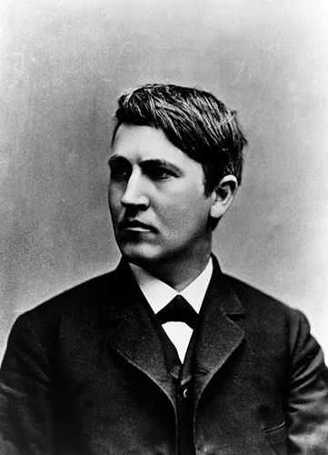  Thomas Edison in 1878, about the time he was working on the incandescent electric lighting system
 | On December 31, 1879, after years of work and thousands of experiments, Edison gave the first public demonstration of the incandescent light bulb at his laboratory in Menlo Park, New Jersey.  An incandescent light has a thread-like object, or filament, that gives off light when heated.  It is run by an electric current. | Look for the definition of filament in the next sentence  Write the definition of filament:  How did Edison’s lightbulb work?
The opinion people have about someone | Edison was able to spend so much time working on this invention. He had earned a good reputation as a successful inventor, so many rich people supported him. They helped him create the Edison Light Company and gave Edison $30,000 to research his idea.
Glowing light from heat  Didn’t have | Edison did not work on creating the incandescent electric light alone. Francis Upton helped him. Upton provided the mathematical and theoretical expertise that Edison lacked.
Silver colored metal  An element that forms diamonds and coal  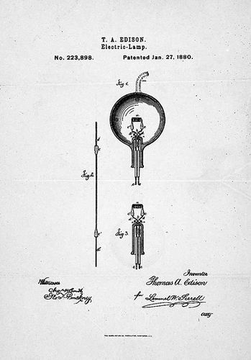 | In October 1879, they produced a bulb with a platinum filament. But platinum was too expensive, so instead they found that a carbon filament provided a good light at a cheaper price.  Although there were problems with the early incandescent lighting systems for years, Edison's reputation as the world's greatest inventor was firmly established. | What was Edison’s discovery and how did it impact the world?

Examples of some of the journal templates:

Double Entry Journal
Write down quotes from the text | Reflect on the quote  Example: "I found out...," "I was surprised...," "I would ask the author...," and so on.

ABC Summary Statements (nonfiction)

- Identify + B. Select a Verb + C. Finish your thought!
(Who) (ex: defends, presents, contrasts, (Big idea, main
describes, suggests, argues) concept)
____________________________________________________________________________________________________________________________________________________________________________________________________________________________________________________________________________________________________________________________________________________________________________________________________________________________________________________________________________________

Somebody Wants But So

Somebody | Wants | But | So

Think of a text that students may read. How can you support students’ comprehension during reading?

AFTER READING
Think of a text that students may read. How can you support students’ comprehension after reading?

Planning for Comprehension Instruction EXAMPLE
Text | Informational Text:  You Wouldn’t Want to Live Without Clean Water  By Canavan & Antram
Standards | 7.6 h h) Summarize text identifying supporting details.
Purpose/ Learning | Students will be able to understand why clean water is important and what will happen if they drink dirty water.
Before Reading Supports | Pre Journal: How would it feel if you did not have clean water to drink?  - Think pair share, then write  - Share out a few ideas before reading  - Set purpose for reading: to learn why clean water is important.
During Reading Supports | Jigsaw sections of the books and create A+B+C Summary statements for the section(s) read.
After Reading Supports | Post-Journal: How would it feel if you did not have clean water to drink?  - Think pair share, then share out after writing  - Add ideas to driving question board for themed unit
Planning for Comprehension Instruction TEMPLATE
Text
Standards
Purpose/ Learning
Before Reading Supports
During Reading Supports
After Reading Supports

Session 4: Assessment
Learning Objectives
- Understand the complexities of assessing comprehension
- Learn how to create a new comprehension measure called a narrative profile

SAVING SYRIA'S HISTORY FROM CIVIL WAR
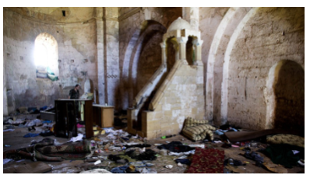
The belongings of Syrian rebels are inside a chapel at Crac des Chevaliers, the world's best preserved medieval Crusader castle, in Syria. The village was destroyed in fighting between the government and rebel forces while the castle, listed as a World Heritage site, also has been damaged over the past two years. Photo: AP Photo/Dusan Vrani
PHILADELPHIA — One of the casualties of Syria’s civil war is history.
Five of the country’s six World Heritage sites have “significant damage” and some buildings have been “reduced to rubble,” according to a report issued this week.
The report relied on high-resolution satellite photos to chronicle damage to mosques, Roman buildings, and a Byzantine castle.
The Geospatial Technologies and Human Rights Project of the American Association for the Advancement of Science wrote the assessment with help from the Penn Cultural Heritage Center at the University of Pennsylvania’s Museum of Archaeology and Anthropology, the Smithsonian Institution and the Syrian Heritage Task Force.
The Cultural Heritage Center has a two-year grant to study how historic material is used in conflicts, said Richard Leventhal, the center’s executive director. Heritage, he said, helps determine who we think we are. Destroying heritage is not only about razing buildings and gaining land, but “also the destruction of people’s identity.”
Earlier this summer, Brian Daniels, director of research and programs for the Penn center, went to southern Turkey near the Syrian border to train 20 Syrians who want to protect the sites. They were taught how to protect museum collections during emergencies and were given supplies to secure pottery and library books, some of which are now being kept in private homes.
Daniels said he was “just incredibly floored” by the bravery of the Syrians. “They are aware their lives are at extreme risk,” he said. “They feel that it is their responsibility, their duty, to try to save these things that are most precious about Syria’s history.”
He likened their actions to what most of us would do if our homes caught on fire. First, we’d make sure everyone was safe. Then we’d try to save the family pictures. “These people’s jobs are to try to save the family photos for the country,” he said.
The report does not assign blame for the damage. Daniels said that the insurgents and the Assad regime are responsible for an “incredible amount” of destruction.
Damage done by the extremist group Islamic State (ISIL) is clearly intentional. One of their targets, he said, is Christian graves. ISIL “has been destroying these things left, right and center,” Daniels said.
The militant group calls itself the Islamic State of Iraq and the Levant (ISIL) and has also been called the Islamic State of Iraq and Syria (ISIS). Levant is the English term for the region stretching from southern Turkey through Syria to Egypt.
Experts are not as sure about the Assad regime’s role although it is the only combatant capable of aerial assault.
The United Nations Organization for Education, Science and Culture maintains a list of more than 1,000 World Heritage sites representing great cultural or natural significance. In the United States, there are 22 of them. Most are national parks.
Syria’s are buildings or towns. They include the Ancient City of Damascus, the Ancient City of Bosra, the Site of Palmyra, the Ancient City of Aleppo, two castles — the Cracdes Chevaliers and Qal’at Salah El-Din — and the Ancient Villages of Northern Syria, which are also known as the Dead Cities.
Of the six sites, the historic section of Damascus, which is Syria’s capital and one of the oldest cities in the world, has been “largely protected from the violence that has heavily impacted neighborhoods surrounding the city,” the report said.
Aleppo has not been so lucky. In northwestern Syria, it served as a commercial hub from the second millennium B.C. and reached its peak in the 16th and 17th centuries. It has seen heavy fighting during the civil war. One of its best-known sites, the Great Mosque, has been damaged, as have many other historic buildings, according to the report.
At other sites, the report found evidence of new construction, looting, and the intermingling of military equipment and ancient buildings.
The next step is to better establish a timeline for the damage at each site. The ultimate goal, the report said, is to “enable U.S. policymakers and other humanitarian agencies working in conflict zones to design more effective interventions.” The report, Daniels said, may also give the Syrian preservationists “a better sense of what they’re up against and where they can better direct their resources and energy.”

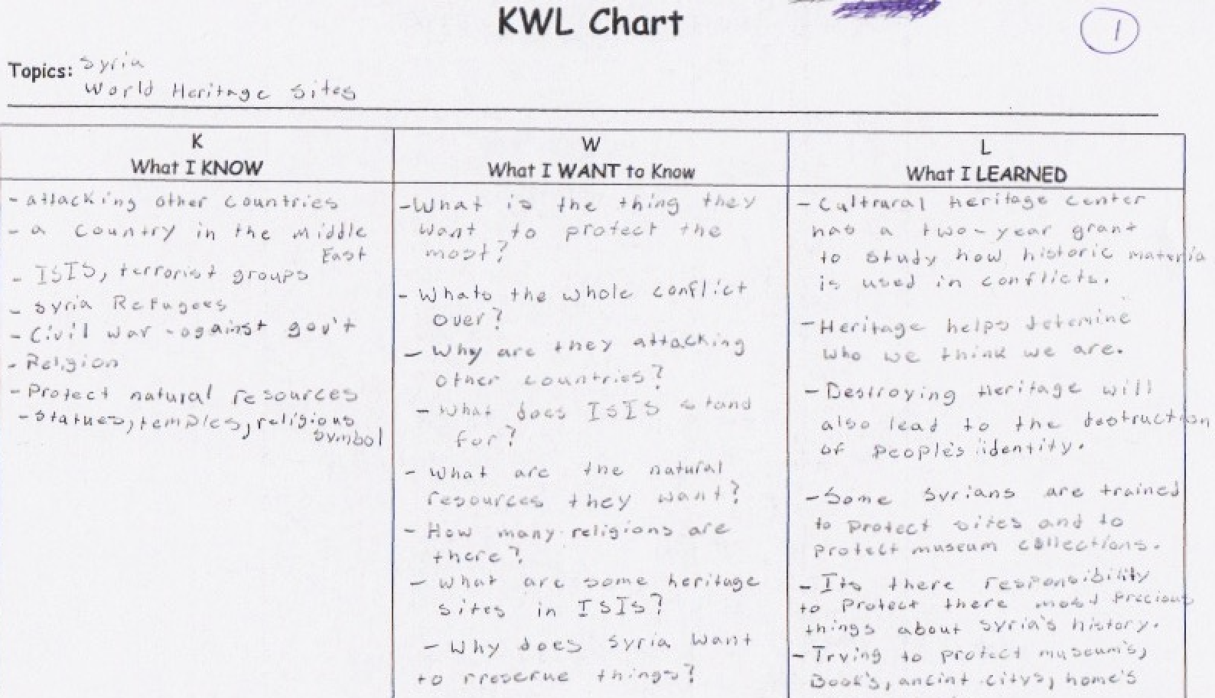

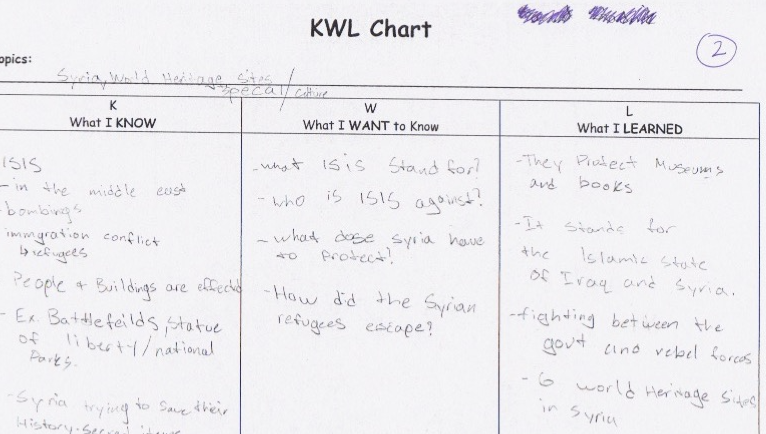

Resources: https://tinyurl.com/washPDresources

